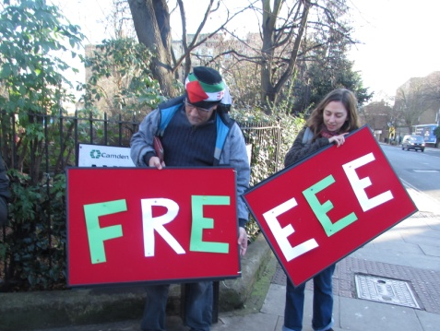
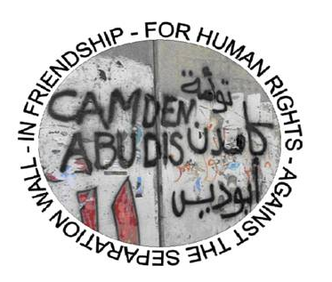
Twinning in Action
June 2015
Linking together for human rights


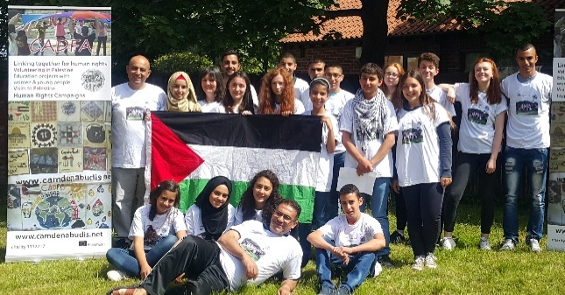
Twinning in Action is a CADFA project funded by Erasmus + and the fund-raising efforts of CADFA’s members and supporters. It includes youth workers’ training and a number of twinning exchanges for young people from Palestine and the UK (women, university students, school-age young people). The purpose of this twinning work is to promote human rights in Palestine.
More information on the project here –
Twinning in Action blog here -
Enquiries to contact@camdenabudis.net

Twinning in Action leaders’ training
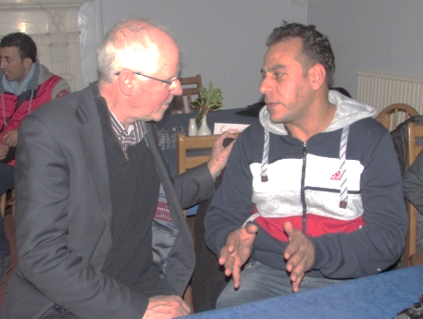
The first Twinning in Action leaders’ training visit in December was a great start to the project. The exchange began in Newcastle where a public meeting with the Palestinian visitors has encouraged a local group to take steps to build a Newcastle friendship link with Palestine. From this point on, the Twinning in Action project has led to more and more new links as well as strengthening old ones.
Our core group of 10 Palestinians and 15+ people from the UK represented CADFA’s three ‘links groups’: university students, women and youth (school students). They worked together over ten days in the Lake District and London to build common understandings and practices in order to lead the next phases of the project.
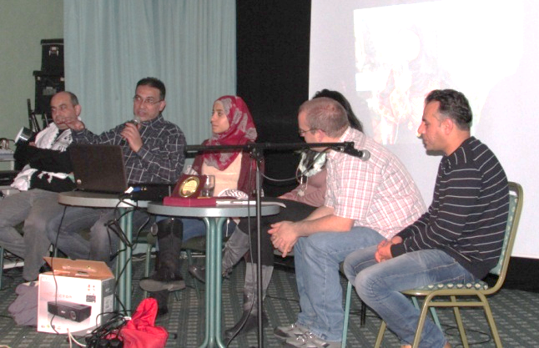
This exchange was a training visit and the focus was more on skills development and less on outreach than the subsequent parts. However there were also public event in the Lake District and a Twinning in Action conference in London which was a chance to hear from other twinning groups, find out more about the current situation in Palestine, and hear the plans of the links groups made during the leaders’ visit.

For more pictures and comments on all of these exchanges, see the project blog: twinninginaction.blogspot.co.uk
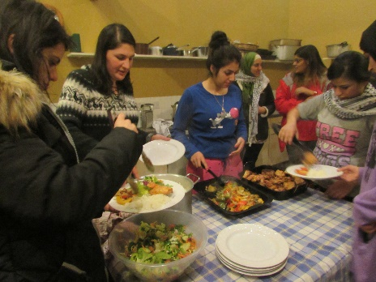
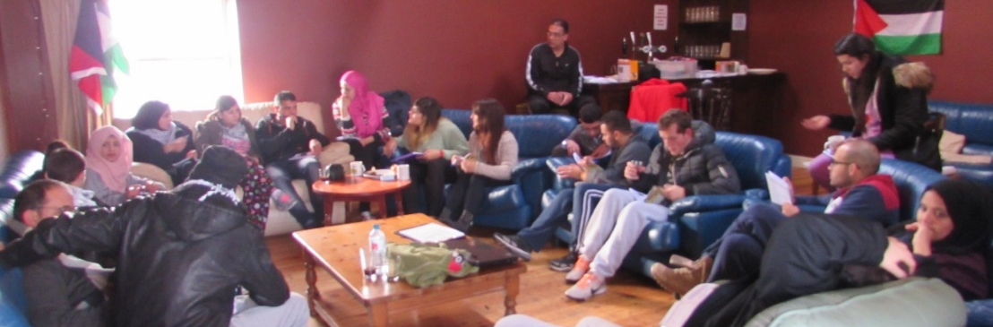
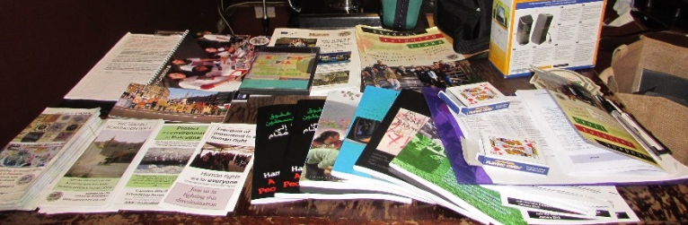
University students’ exchange January-February 2015 The second part of the project brought fourteen visitors from the Al Quds University in Abu Dis (leaders and students) to the UK in January for an exchange with students from the UK that focused on students’ lives with a theme of film-making.
The exchange began in a difficult way with problems with the flights and very bad weather and yet from the beginning this was an exciting exchange: Palestinian and UK students spent a weekend together in an isolated farm in the Yorkshire Dales, cut off by snow, ice and a lack of telephones and internet.
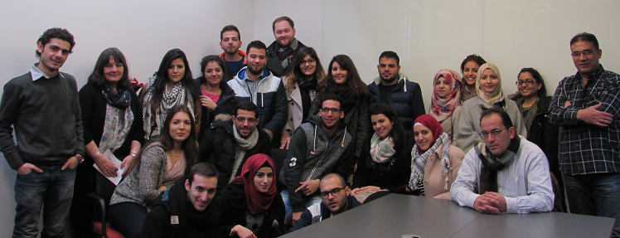
All agreed this was an excellent beginning with real communication and understanding between the two groups well-established by the time they ventured together in small groups to universities and public events in Manchester, Blackburn, Leeds and Lincoln. The whole group came together again in London where they visited more universities, worked on film and contributed to a student twinning conference. Their last day out was to the University of Cambridge. Many photographs and a number of short films were made during this project. The project did well in encouraging the energy and will in a number of universities to continue to work to develop links between the two countries.

Young women’s exchange March 2015.
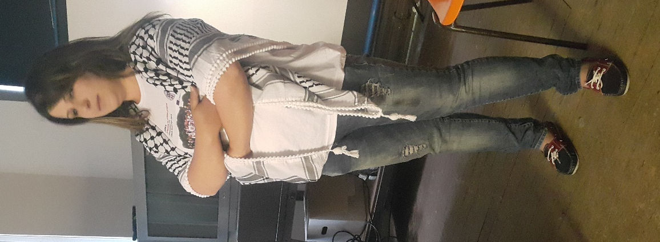
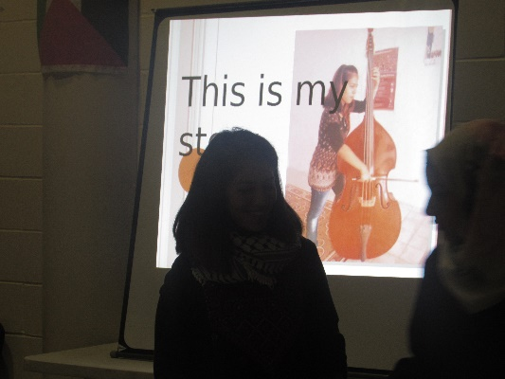
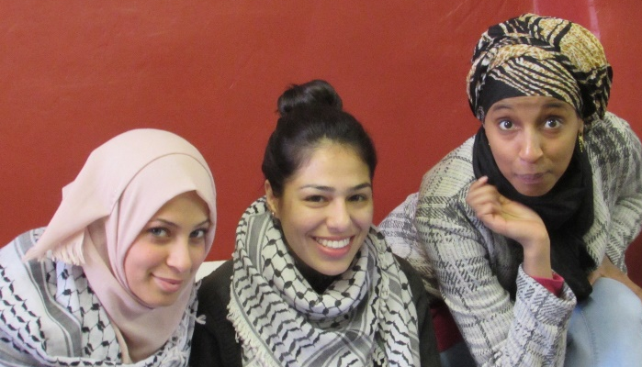
CADFA’s tenth women’s exchange to the UK took place just after International Women’s Day as part of the Twinning in Action project. Fifteen women from Palestine flew to Manchester to join women from Britain first in a residential in North Wales –which had a singing focus > Small groups of UK and Palestinian participants worked to prepare presentations including songs that they would take (in two groups) to Pendle, Blackburn, Mid-Wales, Worcester, Northampton and all of them to London. This visit strengthened existing Britain-Palestine twinning links in Pendle, Llanidloes, Worcester, Northampton, Hackney as well as Camden, and encouraged others to consider new or revived inks in Blackburn, Chester and Manchester University. In each place they met women in local women’s groups and took part in musical activities and public events with an International Women’s Day theme.
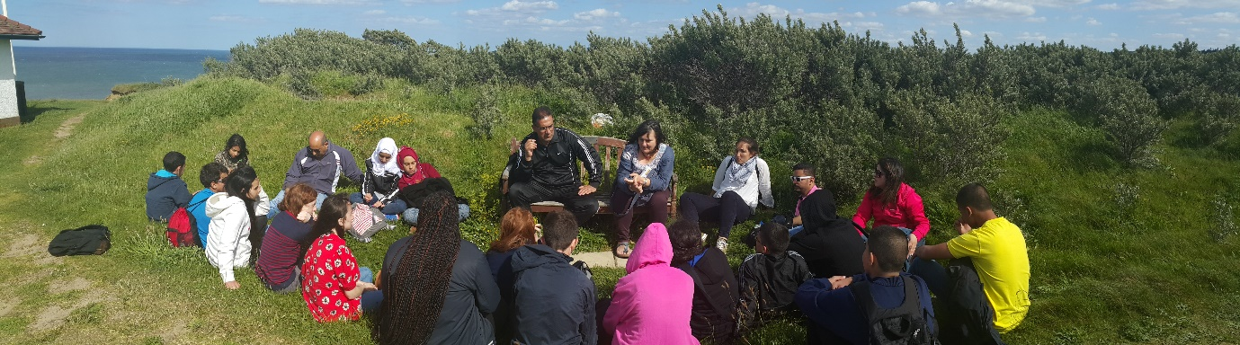
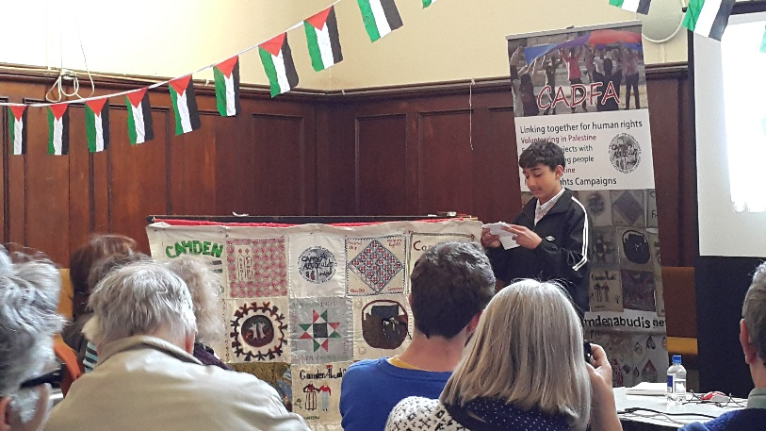
Young people’s exchange: June 2015. CADFA have had young people’s exchanges every year since 2006, and the exchange in June, led by people who had taken part in the December training, was one of the best we have done. This exchange had a drama theme but there were so many other positive aspects to it. Fifteen visitors from Palestine joined a UK group of the same size first in Norfolk with events in Norwich and Cambridge and then in London. During a residential the young people from the two countries told each other about their lives; they then joined in many activities, visits to youth clubs, schools and towns, workshops, ‘prisoner marches’* and public events. This strengthened their friendship and took human rights issues to new audiences in rural Norfolk, Norwich, Cambridge, Hackney, Islington and Camden. The exchange finished with another residential in Surrey to give space to the young people to reflect on what they had learned and prepare to pass it on to others.
Young people from Camden and Abu Dis will participate in another exciting exchange which will allow them and others to look at their lives and in particular to learn about human rights issues in the UK and Palestine. Look out for more information on the public events in all of these visits.
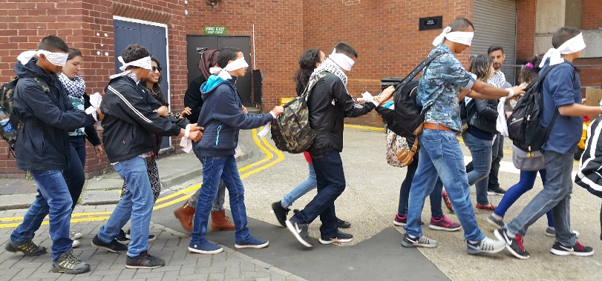
Where have we got to so far?
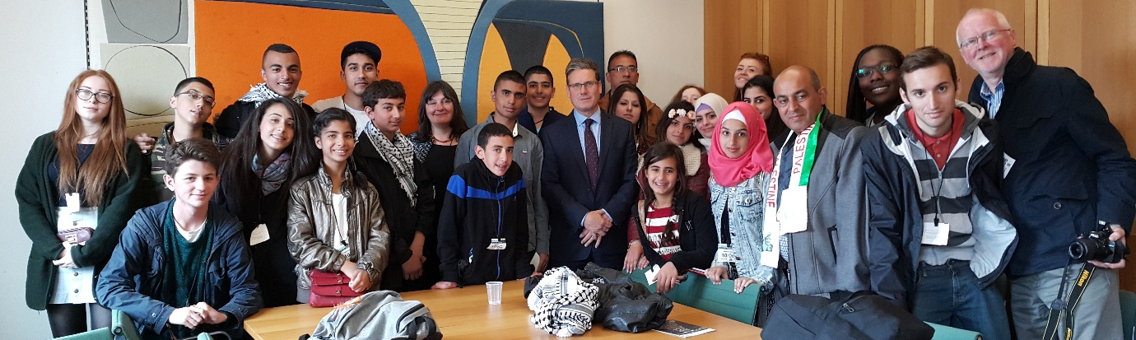
It’s already possible to say that as well as an exciting experience for the people involved in it, the project has been a useful step for CADFA and helped our work forwards. It has for the first time linked together in one project CADFA’s work in our three ‘links’ areas (women, university students and youth) and through our first training exchange has developed the skills of a number of leaders, who were then involved in subsequent visits. It has widened our leadership team in Camden and Abu Dis and in areas beyond them has helped many local twinning groups and aroused new interest in new areas in making links with Palestine in order to promote human rights.
The exchanges have moved on CADFA’s own work. Through the experience of these visits, there has been particular emphasis on two areas: freedom of movement (and visas) and in particular in the children’s visit, the issue of child prisoners.
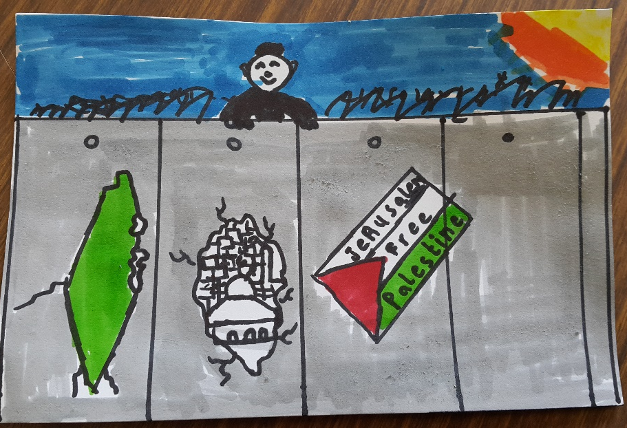
The particular problems that our Palestinian participants had with the UK visa system led us to make representations first to ease it (we were told we had some success as the number of UK visa appointments available in Ramallah was doubled; but more deeply, in order to demand an end to the human rights violations that they experience, we have made the demand for equal treatment of Israelis and Palestinians in relation to UK visas. Participants in our projects have discussed and learned about the issues of discrimination and human rights, and have drawn attention to these through street activities, public events (drama, film, music), petitions, story-telling and visits to policy makers.
Next steps
This project was written with two parallel parts, the first a series of exchanges to the UK and the second a series to Palestine, with a final visit and conference in Britain. In September 2014, Erasmus + agreed the first part only and CADFA appealed and asked for the second part to be agreed. In June 2015, we are still waiting for the answer. The project may therefore end with the final leaders’ visit to the UK or may include four more exchanges, this time to Palestine.

Get involved in this exciting project!
We need lots of help still, including fundraising, organising, publicising, and are always looking out for participants from the UK and Palestine. We welcome applications to be involved in the next stages of Twinning in Action from individuals and from twinning groups and organisations whose aims fit with our own.

FB: CADFA | www.camdenabudis.net | @camdenabudis

